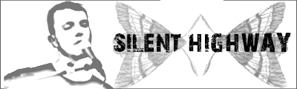
Data

Name: Silent Highway
Genre: Alternative/indie/acoustic
Location: Aarhus/Denmark
Records: 2004 – EP (project name: Storgaard)
(2007 – debut album)
Label: His own Glance Records

Info

Silent Highway is Morten Storgaard. He has been a part of the Danish hardcore/metal band Barricades since 2002, and that gives him a fresh approach to the indie/alternative/acoustic genres!

Two of his guitar strings are tuned totally different, and together with his musical background, far from this genre, it gives him a new and grand sound, which has gained him a lot of gigs!

His musical talents have also earlier been expressed across most of Northern Europe, as he has been the live guitarist/trumpeter in the Danish noise rock band Lampshade during two years.

Silent Highway cuts to the bone, and left back is a good strong melody – wrapped in intelligent and innovative guitar chords.

Silent Highway is currently working on the debut album, expected out January -07.

Contact

Morten Storgaard
Silkeborgvej 361, St.
8230 Aabyhoej, Denmark

Cell: (0045) 4091 2052
Email: mortenstorgaard@gmail.com
Web: www.silenthighway.com
www.myspace.com/silenthighway

